객체지향프로그래밍응용 과제02 컴퓨터소프트웨어공학과 2-YA 20202296 전채린

[예제 3-4]

[소스코드]

// 예제 3-4

public class Exam04 {

public static void main(String[] args) {

int one[] = new int[3];

for (int i = 0; i < one.length; i++) {

one[i] = 10 \* i;

}

String two[] = { "하나", "둘", "셋" };

for (String str : two) {

System.out.println(str);

}

int j = 0;

while (j < one.length) {

System.out.println(one[j]);

j++;

}

}

}

[실행결과]

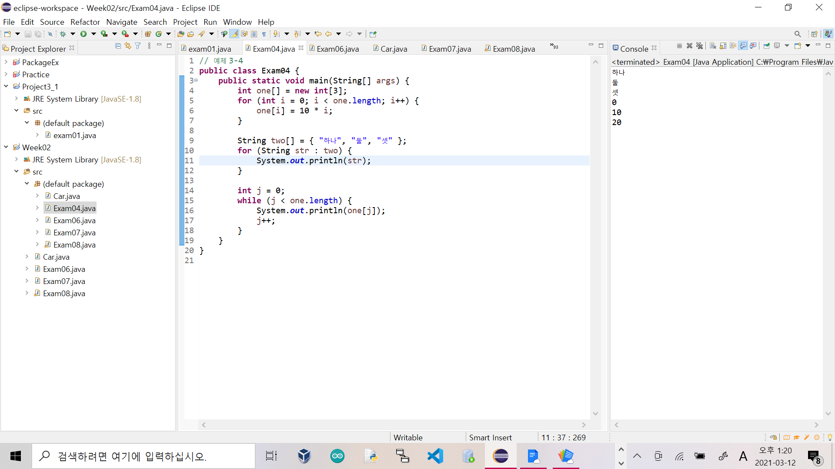

[예제 3-6]

[소스코드]

// 예제 3-6

public class Exam06 {

public static void main(String[] args) {

int num1 = 100, num2 = 0;

try {

System.out.println(num1/num2);

}

catch (java.lang.ArithmeticException e) {

System.out.println("계산에 문제가 있습니다.");

}

}

}

[실행결과]

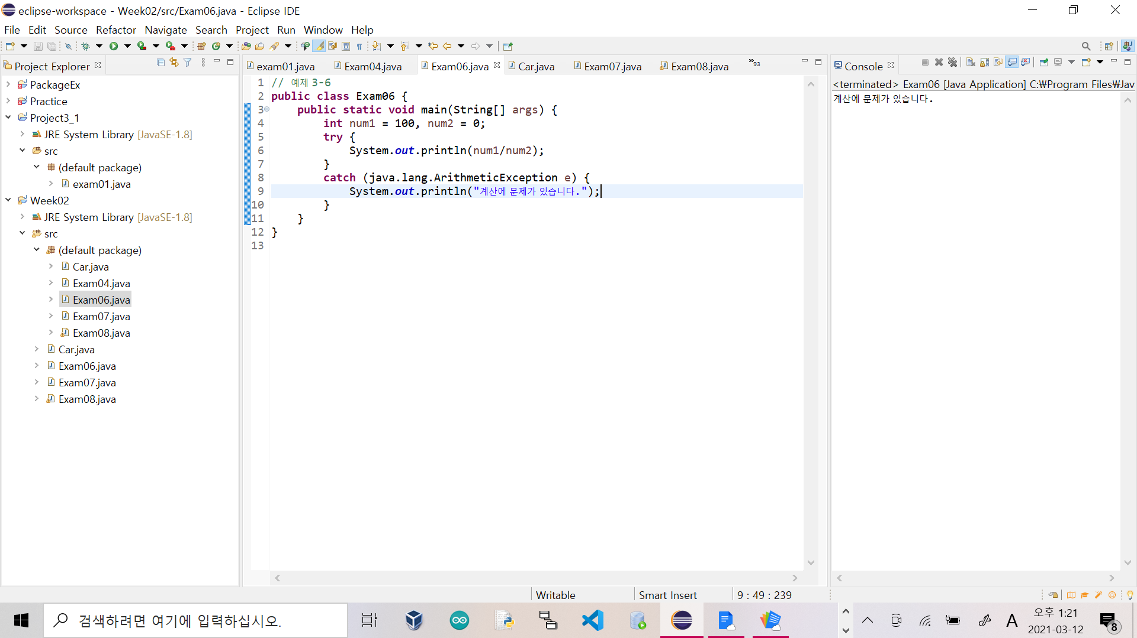

[예제 3-7]

[소스코드]

// 예제 3-7

public class Car {

String color;

int speed;

int getSpeed() {

return speed;

}

void upSpeed(int value) {

if (speed + value >= 200)

speed = 200;

else

speed = speed + value;

}

void downSpeed(int value) {

if (speed - value <= 0)

speed = 0;

else

speed = speed - value;

}

String getColor() {

return color;

}

}

[예제 3-12]

[소스코드]

public class Car {

String color;

int speed;

static int carCount = 0;

final static int MAXSPEED = 200;

final static int MINSPEED = 0;

static int currentCarCount() {

return carCount;

}

Car(String color, int speed) {

this.color = color;

this.speed = speed;

carCount++;

}

Car(int speed) {

this.speed = speed;

}

Car() {

}

int getSpeed() {

return speed;

}

void upSpeed(int value) {

if (speed + value >= 200)

speed = 200;

else

speed = speed + value;

}

void downSpeed(int value) {

if (speed - value <= 0)

speed = 0;

else

speed = speed - value;

}

String getColor() {

return color;

}

}

[예제 3-13]

[소스코드]

// 예제 3-13

import java.lang.Math;

public class Exam08 {

public static void main(String[] args) {

Car myCar1 = new Car("빨강", 0);

Car myCar2 = new Car("파랑", 0);

Car myCar3 = new Car("초록", 0);

System.out.println("생산된 차의 대수(정적 필드) ==> " + Car.carCount);

System.out.println("생산된 차의 대수(정적 메소드) ==> " + Car.currentCarCount());

System.out.println("차의 최고 제한 속도 ==> " + Car.MAXSPEED);

System.out.println("PI의 값 ==> " + Math.PI);

System.out.println("3의 5제곱 ==> " + Math.pow(3, 5));

}

}

[실행결과]

